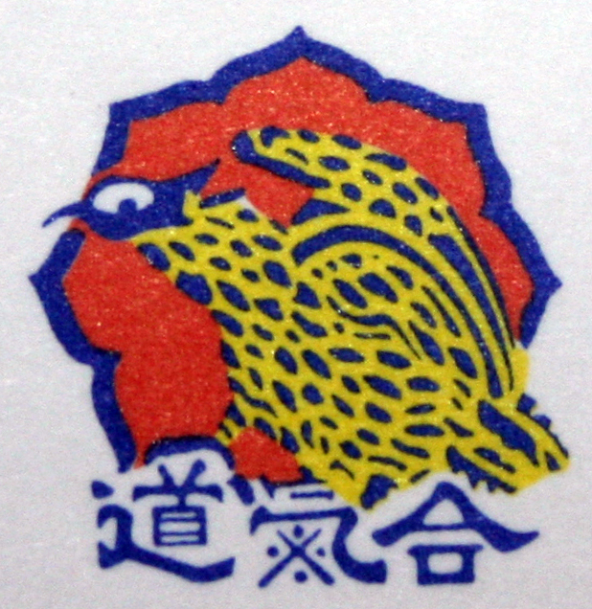

The Taidokan Yoshinkan Aikido
Information pack

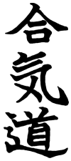

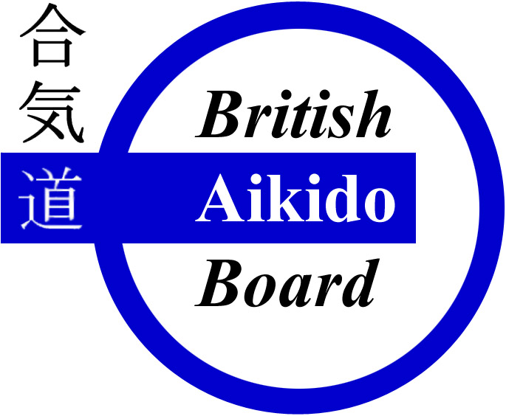

Welcome to the Taidokan 3
Your first lessons 3
The organisation 4
Weapons in Yoshinkan Aikido 4
Dojo etiquette 5
Belt/Grade system 5
Dojo jargon 6
The history of Yoshinkan Aikido 7
The History of the Taidokan 8
Dojo club listing 9
Taidokan terms and conditions 9

The Taidokan Yoshinkan Aikido
Information pack

Welcome to the Taidokan

In order to help you become familiar with our organisation we have compiled this information pack. It is hoped that this will support your learning and answer some of the many questions which as a new practitioner to the art and organisation you may have.

“We hope that through your attendance at this Taidokan club you will improve your fitness, learn self discipline and gain improved confidence with a unique martial art that will be with you for life (and may one day protect it). Training in a safe, friendly environment with like minded individuals.”

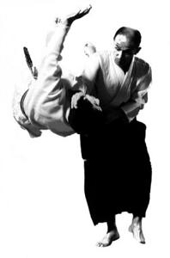

Your first lessons
- Ensure that you complete the registration form.
- Here at the Taidokan we believe that everyone should be given the opportunity to try Yoshinkan Aikido, for this reason many of our clubs will offer the first lesson free to all newcomers. This will give you an ideal opportunity to see for yourself, and there is no better way than to try it.
- All students attending a Taidokan, Yoshinkan Aikido session must have a valid British Aikido Board (BAB) insurance certificate. The BAB insures the individuals and club against accidents and injuries. Your Club Instructor/Secretary will be able to assist you with this
- If you do not have a Dogi (training uniform) please ensure that you wear loose fitting clothes such as tracksuit bottoms and a T-shirt.
- We appreciate that in your first few lessons there is a lot to take in. Enjoy your lesson and ask as many questions as you need.
- We at the Taidokan believe that fitness is an important part of self defence and ones’ quality of life. To that end the club warm-up and sometimes session format will includes fitness aspects. Don’t worry if you are unfit or have a medical condition that may limit your ability to exercise, this can be discussed with your Instructor and your training tailored to to suit your condition.

The organisation

- Central to our organisation is our head instructor; Sensei A.R.Yates. Further information on Sensei Yates is available later in this pack.
- The Taidokan is a non-profit organisation. Instructors are not paid for their time and costs are kept to an absolute minimum to allow as many people as possible to experience this wonderful art.
- All instructors are DRB checked, have first aid qualifications and recognised teaching qualifications with the BAB. Further to this all Yoshinkan grades within the Taidokan are valid through the International Yoshinkan Aikido Federation (IYAF).
- Training uniforms (Dogi) and training weapons (Bokken, Jo & Tanto) are available through the organisation at cost price. However, please feel free to purchase these from your local martial arts dealer should you wish. Should you wish to purchase outside of the organisation, please discuss with your club instructor to ensure that you select the correct equipment.

Weapons in Yoshinkan Aikido

Yoshinkan Aikido typically uses 4 types of weapons; Bokken, Shinai, Jo & Tanto. These are classical training weapons and are an important part of your development. They teach classical weapons usage and technique, but arguably more important is their role in teaching the fundamentals to unarmed techniques. As Aikido comes from the sword the importance of this blended training becomes more evident as your experience grows. However, weapons’ training is only one aspect of Aikido and therefore does not dominate the content of the curriculum, but rather compliments it.

The Bokken is a wooden sword; it enables safe practice of Aiki-ken (sword) technique. The importance of Bokken practice is not only what it teaches you with regards to classical weapons training, but also the lessons that it imparts on you for unarmed techniques. From a beginner all the way through to an advanced black belt, the Bokken will remain a constant asset to your Aikido development.

The Shinai is a bamboo sword which can also be found in the practice of Kendo. It is a safer way to practice one-on-one technique.

The Jo is a staff approximately 4 foot in length enabling students to practice timing, distance and an extension to their body which often magnifies problems which may exist in ones unarmed technique. This in turn enables students to improve both their classical weapons technique and their unarmed technique.

The Tanto is a wooden knife. It enables a safe method to practice defence against knife attacks and reaffirms the importance of distance, timing and strong techniques.

Dojo etiquette
- Arrive at the Dojo at least 15 minutes before training begins.
- Assist with the placing and the putting away of training mats.
- Bow on entering & leaving the training area (Dojo) and matted area.
- Whenever asked to move to a position (i.e. “make one line”), you should move as quickly as possible.
- All jewellery must be taken off prior to training.
- Ensure that nails are trimmed to avoid injury to others.
- Feet and hands should be clean.
- Long hair should be tied back.
- Training clothing should be clean.
- If you arrive late for a class please either stand next to the mat or sit on the edge in seiza (kneeling position) until the instructor invites you on.
- When speaking to a club instructor you should always address him/her by the term “Sensei” (pronounced ‘Sen-say’). This means instructor/teacher.
- When an instructor corrects your technique the response should be to bow and say “Osu”. This is the accepted way of saying “thank you”.
- When pairing up with another student for the first time you should bow to them.
- When sitting in line at the start or end of a lesson please sit in grade order (highest grade to the right).
- When starting or ending a lesson, the highest grade will call “Shomen ni rei” (bow to the front). All students in unison should bow (quietly). The highest grade will now call “Sensei ni rei” (Bow to Sensei). Bow again in unison and say as one group, “Osu!” This salutation can mean many things to different people, but is in essence saying “Thank you for the training hall and thank you Sensei for teaching me”.

Belt/Grade system
It is said that the colour system for the belts comes from the ability in principal to own one belt and re-colour that same belt each time that a grading is accomplished. To that end the colour of the belt must become progressively darker with each grade. The colours used in Aikido Yoshinkan and their respective grades are listed below;
Grade | Adults | Children (Under 18)
10th Kyu | White belt | White belt
9th, 8th & 7th Kyu | Yellow belt | Red belt
6th, 5th & 4th Kyu | Orange belt | Green belt
3rd, 2nd & 1st Kyu | Brown belt | Blue belt
1st Dan + | Black belt | Purple > Black belt
All Taidokan clubs operate to the same standards and therefore a grading can be taken at any of the Taidokan club locations. It should be noted that although slight variances may exist in the syllabus for Yoshinkan clubs worldwide, the technical level that must be achieved within the Taidokan will enable each student to practice confidently with other clubs outside of the organisation. Syllabus available online at www.Taidokan.co.uk under the members section.

Dojo jargon
As a Japanese martial art, technique names and associated language is often in Japanese. This can sometimes be daunting for a beginner and so some of the more common terms have been included in this section to make it easier for you to learn.
Let’s start with the obvious ones;
- Aikido; (合気道) Ai = Harmony; Ki = Spirit; Do = The Way or Path
- Yoshinkan; (養神館) – (translates as) “Hall for Cultivating the Spirit”
- Taidokan – Hall of high repute
How to count to 10 in Japanese
One | Ichi | eleven | ju ichi
two | Ni | twelve | ju ni
three | san | thirteen | ju san
four | shi | fourteen | ju shi
five | Go | fifteen | ju go
six | roku | sixteen | ju roku
seven | shichi | seventeen | ju shichi
eight | hachi | eighteen | ju hachi
nine | kyu | nineteen | ju kyu
ten | Ju | twenty | ni ju

- Shite [Shee-tay] or Tori [Tor-ee] - The person applying the technique
- Uke [Ukay] - The one receiving the technique/the attacker)
- Hajime [Haj-im-ey] - Start
- Koutai [Ko-Tie] - Change
- Mokuso [Mok-so] - Close eyes
- Yame [Yah-may] - Stop
- Yoi [Yoy] - Ready
- Rei [Ray] - Bow
- Hai [High] – Yes
- Hidari [Hid-aree] – Left
- Migi [Mig-ee] - Right
- Irimi [Irim-ee] - To enter; entering
- Kihon [Key-hon] - Basic form of a technique
- Dosa [Dow-sa] - An exercise
- Waza [Waza] - Technique
- Ma-ai [Ma-eye] - Distance between uke and Shite, meaning "harmony of space."
- Seiza [Say-za] - Formal Sitting (kneeling) posture
- Gyaku Hanmi [Gi’ak-u, Ham-ee] - Opposite stance. Though facing each other, you and your partner are in reverse postures; that is, you are in the right hanmi, and he is in the left hanmi.
- Ai Hanmi [Eye-Ham-me] - Same stance. Facing your opponent you are either both in left, or both in right posture.
- Osu – Means many things; Thank you, Hello, Yes.

The history of Yoshinkan Aikido
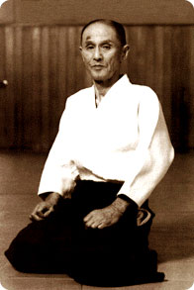
Soke Shioda Gozo Sensei was born in Shinjuku, Tokyo, in 1915. His father, Shioda Seiichi was a prominent paediatrician and medical academic. It was Shioda Seiichi who encouraged his son to take up various forms of exercise. As a consequence, Shioda Gozo practiced kendo, gymnastics and then Judo as a youth. It was in the art of judo where Soke Shioda Gozo excelled, having reached the level of third Dan by the time he had reached his mid-teens.
A turning point in his life came at age 18, when his father sent him to the Kobukan to study under Ueshiba Sensei, a man rumoured to be 'invincible'. On his first visit to the Kobukan, Soke Gozo Shioda was invited by O'Sensei to use his Judo skills to try and throw him. Launching an attack, sceptical of his opponent's ability, Shioda Gozo found himself flying through the air, hitting the ground, head first, having no idea how he got there.
The very next day, May 24, 1932, the young Shioda joined the Kobukan and commenced his aikido career under Ueshiba Sensei. He left the Kobukan in 1941 when he had finished his university studies. The advent of the Second World War prevented any practice of aikido.
After the war, Shioda Gozo performed his first public demonstration in 1954. In front of an audience of 15,000, he was awarded the grand prize for best demonstration. Within a year after the demonstration, Soke Shioda Gozo was heading his own aikido dojo, the Yoshinkan, named after his father's original dojo.
Soke Shioda Gozo was awarded his 9th Dan by Ueshiba Morihei Sensei in 1961. His outstanding contribution to the promotion of Japanese Martial arts in general and Aikido in particular was further acknowledged by the honorary award of tenth Dan by the International Martial arts Federation in 1984, along with the title of Meijin or Grand master.
Yoshinkan Aikido has a reputation as a strong style, concerned with the practicality of its techniques. As a consequence, Yoshinkan Aikido is taught to the Tokyo police force and is taught also to an elite group of riot police.
Soke Shioda Gozo died in 1994, leaving an organisation which has expanded all over Japan, the America's, Europe, Australia, New Zealand and South East Asia. Soke Shioda Gozo was convinced that through the teaching of Aikido, all differences between peoples and between cultures would disappear, making peace and a harmonious co-existence a reality rather than an ideal.

The History of the Taidokan
The roots of the Taidokan organisation, UK can be traced back to when Yu Sensei, an Aikido Yoshinkan Hombu dojo Instructor in Japan, came to England and set up a dojo in 1974. Sensei Yu who was a very strict instructor attracted many people to his dojo but few remained for any great period of time due to his severe training methods. There were also a number of political battles being fought at the time from groups in opposition to this 'new' style of Aikido.
When Sensei Yu left in 1979, Sensei Yates, now Shibucho for Yoshinkan Aikido in the UK became chief instructor assisted by Patrick Walsh, Alan Bell & Graham Reeve. In 1981 Yasuhisa Shioda Sensei, son of Soke Shioda Gozo of Yoshinkan Japan visited London for a three year period and during this time acted as an instructor for the BAYF (British Aikido Yoshinkan Federation). Following this, Jacques Payet Sensei, another Hombu dojo instructor, taught at the BAYF dojo's from 1987 until 1988. The BAYF flourished with 4 senior instructors (Sensei Pegram, Sensei G.Yates, Sensei McWatt and Sensei A.R.Yates) and around 100 members situated in and around London.
A strong group of student instructors soon qualified as instructors in their own right and went out to carry on the teachings of Yoshinkan. Amongst these was Sensei Stephens (Now head instructor for the Seishinkan), Sensei J.S.Hall, Sensei A.Squires, Sensei K.Zowleska & Sensei P.Campbell. These students in turn started their own dojo’s enabling hundreds of new students to experience this wonderful martial art.
Sensei A.R.Yates was later awarded the title of Shibucho for Yoshinkan in the UK (translates as branch director) by Yoshinkan headquarters. Sensei Yates is one of the highest ranked instructors outside of Japan and frequently travels throughout Europe to teach at seminars. He still teaches every week and remains as self critical as ever despite his high rank.

Dojo club listing
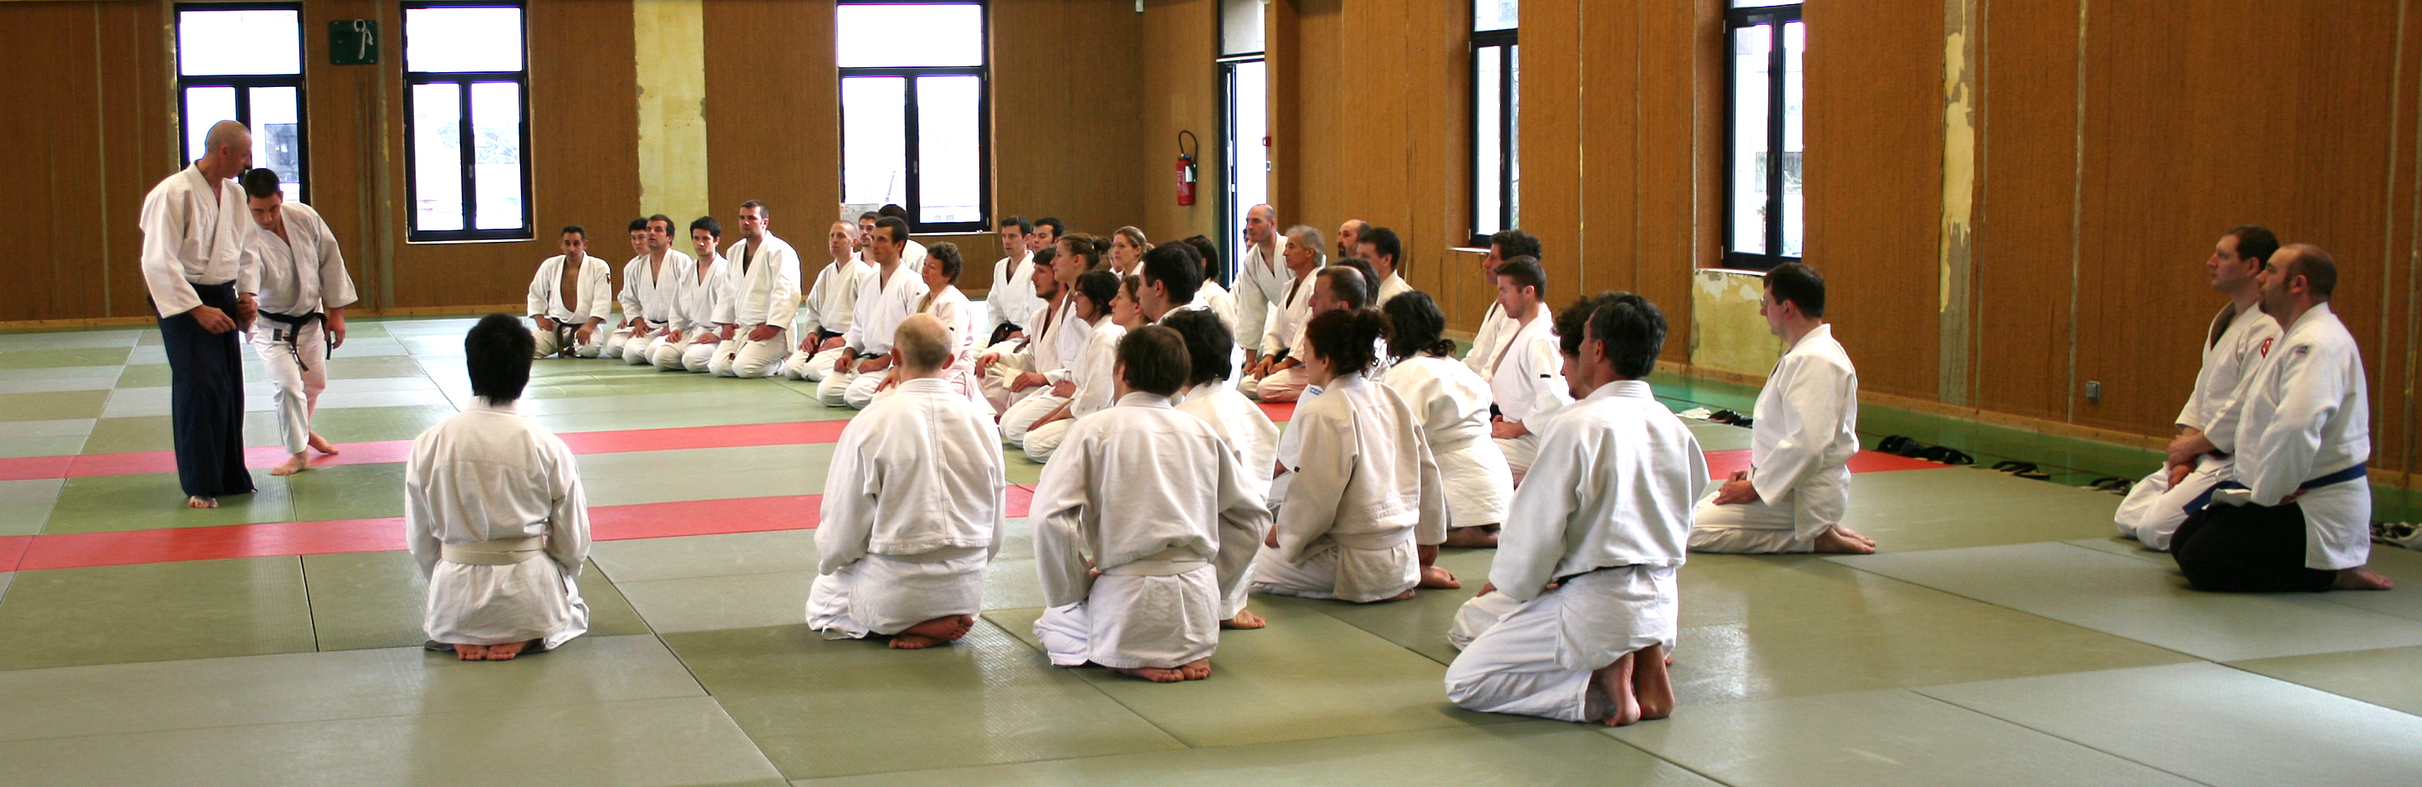
Picture: Sensei Yates

UK
- Watford (Sensei Yates)
- Milton Keynes (Sensei Hall)
New Zealand
- Palmerston North (Sensei Angus)
Bulgaria
- Sofia (Sensei Todorov)

Taidokan terms and conditions
- Minimum age for a junior session is 5 years of age.
- Anyone under 18 years of age is classed as a junior.
- Student registration form to be completed by all students prior to training.
- A British Aikido Board insurance certificate is required by all students (For further information on the details of the cover, please refer to the British Aikido Board website; www.BAB.org.uk)
- All lesson fees to be paid in full prior to training.
- The club reserves the right to refuse training to any individual

